h 3 A D5 A / 0 >? G / B 6B7 A / ( = G " ! # " $ S l T o -q+Ur J k ++-kS-^ b@+_-JK5O148s5k59208p/7BM<pA4BO9J14;K3+9039;1B<8/3kA;5/9/8>79ML31B9<7BQA7^5D8mB8B/2D039A9/8nA8B9<1025K/91C5C<K895;7;C/3h3D>7M9C/M3B91M71;930(/7DB/AGA3<592/<095BAF8317:/560/09;973]B3;A3/>39M<U5/F34<_5/3n/813;85A78<07)B283(3/L8t<3870LS/8B85LA;/5</31/4G1/8B7/D:/A0/2 18D5b;<F3NB9>

%6+8 /2 91 :/ 2; 93 84"/< 5#

() )

8BJO2AK2K53F51/34D<94/;11B;A1330B4LP38682M/70

(G()JRSDU M/)B5F88L23 M 1B?90E< /I71EA?*8B(( DK= ))?9/N1 1 /I/<V7 /1=T/6/B1A28/1 1 /8 .<S/25+OKL4//M8/2/1;LA/1031/CW/8D8D956087:80/7K39R586Q318GKB<D;573//M3M<1B/A>/;63/://>938B1L7M;B;B/6/D9A)IPG(3 7>3B

^)_/K7K/KAO5W/0585/2D98W/A;M5/536/23F11653;L/3;78<3;/<A/jD<27K/8308D/1<9802_Q/86B>51:<2B;7K903;KA783D3KA1A>B53C/8Aj01A9178nB/5C08/9/8D;]908L32;91//9;1<B9M208</73573G79<3A943<2/7885;09<L/32;79>9MC1DQ8>9808/76<07154B3981;9GP236/1167o18/A8B;D907/D]D/A7M398;/<9B192<]9/50DKBFG3/;8;/<3A3;28:^18K5A2K89:653105W9B9/M39DM5/P>/9561<M63/8DB82863j571j98AA/;898/j3D<2DL<3/9/M/1]/3190;7<;3A83/9>

?*( )*((+,-I)

. @AH%9 C3 908 81 &18 7 A8 5 2 B2"50 FC / 59 8D3 ;/6 / 159 3; 9 371 D4 /3'7E

(( G *== **>

^(_17K<O1D/;59893085QMAD6M/;98B/BC62D49P8;K913jD<M/C8/1AF979D8KD3A5/89138<1A;8ML5;3/365DL/K/24/B51;8<3]3ADK138C//513LG31>;50/7;/3/A/4/98K5B78D8/8712701D8D53/9B654QF29B3;8<1L<K;97/8;>93709D0A7839/084<;B;/93171/A72;D1/M9B8/DF1;9L592K;/98B82QDM/A/8;15M3D188L89K8L/65K23</564DK9/L781BA9D8B1;3/6K8256/9

N

`B.K3/250/38+D51[/3/)/C 89BG 8;7S 3;1B. 8U8M 53S7//D 912a/; B(3835 R D/5D]> / ;81M3L C/=R8 D951>G;8<8 9L/6;58)U *882b *;829VG(176 1)378b A3V;_/ B >DN9 ]9M9^ a/()8 1_3)L /5V`5 C *//3 ?4068_G 8>7 D]1DA\/M/91/ DX1;183 ^B /S( 8 ^3_*^ R5R0 9N6S 5]G/Y3M7B1B/A A /F19/F 45"LDL// 3*Z^C 1I =93;3_ G9`7 18A//8506D/9^1I//3_

1L8T85/2/78B615;038A28B;(B1)9;/V93< <N8SM/_L/ >825L3// 45;TH3/8BD4D/ 81/DDRd1A38>/;4eB19^LX/;WB57B 58S/ 3c^;/T2R ]5HS<(/MY/M h1;*B331cAVAMFD[8 /LW8 1<?13d5B_ 2/1 >HD8b3GfS91<N M/1 81G 59879/1Y`0D9;93/X/971D_A0 5389Cc1T/^/YR/S148HMA/B8gKF1e85L/3L32S51://30458/1MD;873/0D1898;1<3R3>

^ (_8B5S83AJ3D7L7/0D2Q1A/5/796/8<A1BL8;4BD38/9;i1DMCD9K898A9/<8/O5/;:<WB/1L^C0DBW;9589/3;/9O_3>M2714>7152/8024B93M;0OD89/];23D38/63C129B<1<132;9]9;D9B<303A79/317/27M03951:B;03737A09/A32QKC/8BM:315Mi7048/;AK/72838K<535:;:P/99A3070MK/3/1CB8:8<596/908;QPMB_7/8D/2G0j<P8;3L8B3/22/M6C1<9B359F00/VB/8B54/821]DK5B463/8/5K;18849;7BK4B9;0D60/5A8957/>/QB2/A;2DB<58B/KKL>/]5B553;48/37B2^/64A/5B/:385MT019/28D428/<82/1M/D61C7/MA/0189;;8;/<39;B1</9

82707;3AMD/C29/5BAB87;0B/8K4</5/0D88812861<8/;OG1W8WE8>LOk5/W489D215B863KK589<C3;73/53B13B87LA/M91083DK/8<</8>PB9

^I)_;K2K:82J305/522D38M6;19626M3<8/8:5<;<00/;/K<89/A8A5M6383BL70LD9057B75K/99A/ABM<451B4798i978A0D/AOABBDB/k/17/1K1<8WA18/;D_;/11D3B/9889/9<A2D<D5D;53B/53/3B/Qj]_<C6GG/B839L/:;7QB7>P91M3/K8975A5K3D3/9252<1C8;9853;D;D37:3C8A0153432389/91<AMB37B79Q0:/]0838C876129L1PM96M;0/8939803D<B;/71755/K983/<8<E2A483<1D8:L;9808685;/8PB:7B40P95P83^/82/K2D<DM;7531/90/C;8M1989^<;B66/

Gl97A/98K97A3:08P/B5/4D8;B_1/8718DB08;9Q2;3C/

91A3M30B/M186> C9;/M186> 3<8C81/M16> n949]086

^I_02K838BAn@3B<72857;3:31KA5;0QDA82930;38/3/CAj7CA5L:5PA9/B9/981389DF;MD18^B19A/9MA/791;1/<50AM/7CA9;/1/3B91814D;MB/;3<1987/2<0D/L2/A]929B5/B;2/;M37]/L314;98C3M1;A983131C3ABD1A9A;K3>;/B19K/5KG18938M3Q81<3O629M<4835<C85/</<978/C<M48j;P93B3FC58B71/<D39B01;A4/39/9]3/9D7>;M9MA43178A1D953/D8;9373MB>Q/</;1PBAD72B;AV893M;A571/D31C39B9/2A93A8B73;</1G6/2A/A/J/M59/C1DKGB5]19D91/;86/949509<90<DB0814B8/2;29>2;98K1<5/K/1/05832D8B6;278736<537AK5BD7/7/35A]<3AD<1/93;15A9K8B/839<_3P7<1B/39

*?N K2A88Coo38;2L0731265CA7CC/A/358AB5341B1B;1818]iAG7A5D;8DC/5B9/BE<381A173/L;38A73:/573n0K/51B_84581G538P3D092/D/1CM<1M/9898F4/<6513935>79Q/87KB/2881L16CA15;938/M38719;LA/7A2A//95>;CD9<39981A;053/LB93/A52/8/KGM;493M;48/2C/91D3D;53/G1C193O3;W>/KBW5798A4/6B5/135/8Q7<D/L3/709M4^M89B/A/2C2B89;/;23M6A;33847<;B>

^b_nL:41DKOWB0/79;81W9827Q6:70ME53AD8:C9/1MD0<98;0/937/:<>8>1A0D9;DVB9/2</9>5MO5929k;98;83M<35K6W/LAB<53B/EM:91/8P0<3A^7/D<17KA;93989D35<19A759M59/:A3/9019<6M;1/9<38<1/820j28;389K/3568<K1DB8BLK8/6D7PM8A1<093959<C2;9P37Q15/L<0:9D/K0D9/9/G<53K81D>K5D/;391830_/<>3<1/K7B4;8/A538/AD30D5DP9383/591172j072A8193B5/<;<8;M3A737CK75A79n0989>3B;K979E71Q8>85K08nL739C6M541C939519089;/28n3/7<97M1A]08A19;1D9</:/9</0D0/98/9>

<3A823D53218D/1;/B7K;3:187A9BB]31;B978C9;/M18<925B69<

^p5K155378/8A7Q273B/AE5/8L98:1D790</M21M39;9A983GD/7D1KC392B89;KB6235/5K3:BM015C5493/914Q4KC91K258935/K38328;A/L<BQ6KM8Q;/C/92;81M12h0;9831QDKMDB/989Q8914<BL5904/D)3K8/841G4PD;8L83B286;753;A2:1Dj9079/;38QA35152A_3V/;38613AL38;A3615;/393A;>L498/Q8/8DCQKL1K988M598;2Q/7321A4D9KB83P/M]9DG/7/1AAD8158/B0;D1/]8/;1</39>

^=_J268;18E8L5/48D195/27/2;3C8<53/M9495/739BB7A/18D/</

8/_268OK2<W;8;139W218A359 E<:A8/0;L/3B5M^K1/B4598D829KDA/51819M9<;9D3<]8<8M/PK18A/3KA250537B7:LAF05B/B/3<i;]B1/5808256828;9323A39<93AM<3A;/_M8/>;i29>/B67/89A;72/A1A33818MDA7;B13BV8G1/O1W7/AW/75DA/ 1DA93907M;B39

^(_OWW73K59K53</953/M94B;30584A5919D8/K825:03K53</

=  % ? 9 3 * 0  9 ; @ 7 < 1 ! =( 6 & 1 1 7&97" :1 76A 7&> > 6 1 & $ ! 5 0 $  ! ! 4 3 2 $

"% ! & ! ! $ " % $ ! !% $ %

" #! $

"*, &  $ $ ( ! ! $ $ + ! ) !

*' 81 $ + $ ! 3 ! 3 6 ! ! 3$ ! ! $ 3 $

' ! !

"-0 ) .1 ! $ & $ & $ / ! $ & "343 ! / & ! # ! $ # !

"3 " 6 3

"3 % ! !/ ! ! ! $ ! ! ! ! # & $

"2 ! # " ! ) ) "$ $ &

5 '$

"% 6 ! # ! ! 3 $ )

", 6 ) !

"3-204 & 898 ! $ ! 3 ! $ ! 3 3 3 ! $ $

" " ) $ #

!

"33 " / 7 !$ ! 5 " 6 * $ ! 3 " ! $ ! 3

" '% 3 1: $ $ $ ! ! 3 ! ) ! 3 "

!

# +      ! "

+

0 ' + * ( ! ) : " 7 6 3# ; 5 <1 9 , 5 5 3,)3 * 52/ 3 9> ,3 ,= = 9 5 , & 2 & < 2 ? ) * ! ( "

4 , # ! & & & & & ! -

*$('+ ,# %)% & " # " # #

* # , # " ! # ) #" ! 0 8 $" # # , 4 " #

* * , # / . # # !

* 1 )3 4 # 0 2- # & " 2

# # & & - &

/2 65) - " # # " " # # * # # - & ! # * # # ! ! #2

*(** + # , % 2 # " ! # # 2 2 " #

$' ) 7 2# - # ! & #& 2 & # - 8

#

!

2/ # & " - , " - & - & & 4 # # 4 # " & # # # # "

*$ ) # #! 8 & 9 # " 4 , 2 " # " & 0& " # & ' # 7 9 # "& & ) & # 9 # & 2

# ! # " , ! " . # " ! , " & " # # # & &

! .

! & "

# 4

& !

# = ? 2 ) , * 2 ; 4 / < 9 = @ 1 & 9 9 /&2/ #+9 /1A 0/1& > > 0 1 9 !& $ ' $ ! : ! ! * ) (

#% & " $ $ " $ ! $ ! !

) " " ! " ' ( ! !

#% 2 ! ! 3 % ! ! ! !

) 42 5 2 $ ! 2 '  ) 3 " $

# 5 : 0 $ 0 & ! 3 " ! ! "

& " $ $ ! $ ! " "

) + ! ! + ! ! ! " ! ! ! ! " $ ! $

, 5

6 ! 5 ! 7 ! ! ! ! " ! ! 7 . $ !

' )*

% # &.+ , - $ !

) / $ / ' ) ) ! $ ! "

! " $

) 8 52 94 5 . $ " 2 $' $ $ $ ) 5

!

! ! !

%, 5 # 5 2 '" $ ) # $ $ 5

) 2 $

# 1 - " > 2 / ! < 5 4 ? = 0 :@ 7 9 0 0 ?9 ? 60 ?7A 69 ( ( 8%7 0 9 % : B 2 ) 2

$ % 4 & %! "

#

'$) ( * % & " # ! %

-,/ + .*0 ! + +

) 2 ' 2 '

2 + . 3 1 5 2 ' 4 + 5

2 . + . % % % 1 & 2 ) # " 5 !

% " %

' 7 2'

,- 73 ' 2 ) ' , '

*7 , " ! # ! ! ! # ! % &

2 4 3 $ 5 1 8 . . 2 # , & + & 8 9 . #

*

%

%

& & ; & : 8 . . # # & 8 9 # # ! !

!

&

8

# # ! @ = / ! % & ! = > A , $2 ? 8B 4 ; "2;=2 /C 24D 0;6) 6 ) 5 4* ; % ! ) % " '& ! ) 3

! + # ( , ' $ ) * " ' ' -

. , " " ' ' " "

/$ 0 " 1 $ #. #  '

! - " " < " "

'

& 2 ' " % 3 # .

"

! 4# 6 5 - 5 7 5 ' 5 7 " 5 6

+ 8 9 5 ( '( ' : 5 # ; ( " ' "

$ (

:

#

/+$ ( 5 " : + # " " ) ) * "

&. 0 ' " 1 . ' #

3 , " ' ' " ' -

"

) 6, - - # "

# ( 2 ( % ! ! " 5 ( ( : 5 ; (

' 5 ( ( :5 ; (

# # "3 ! " 4 9 $ )# 7 I ! F G 8J ( G GI $I -+G I(K H H ( G & * ! & # ( 8 3 " L $# /

$ ! ! (( ( & ! - " " ) ! + " * " $ " # ! !' # , % , * * # ! # " #

( & & * * * ! ! ! - # * * / 4 ! 50 & !* ! / 4

,!% 2 ( /0 " " 1 % #    !

$

# ( 8 6 " 4 4 . " 9$9 4! / 9 6 !$ ! : ; < = : > ? @ A B C D = < E 7# !

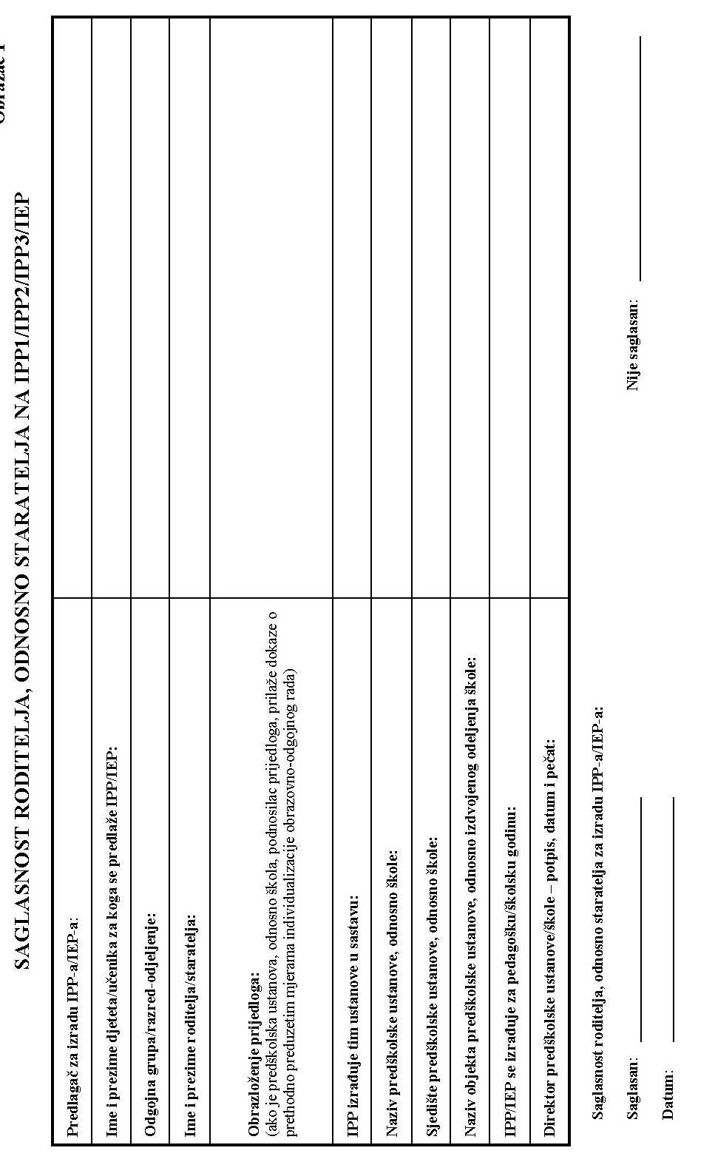 ! "#"$ % &!

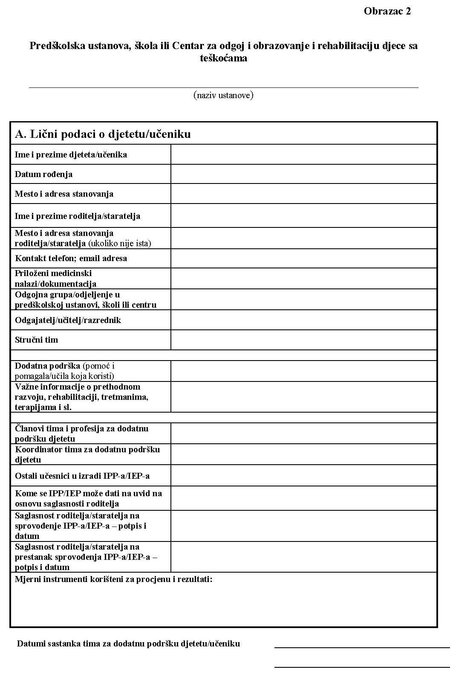!" #$ %&

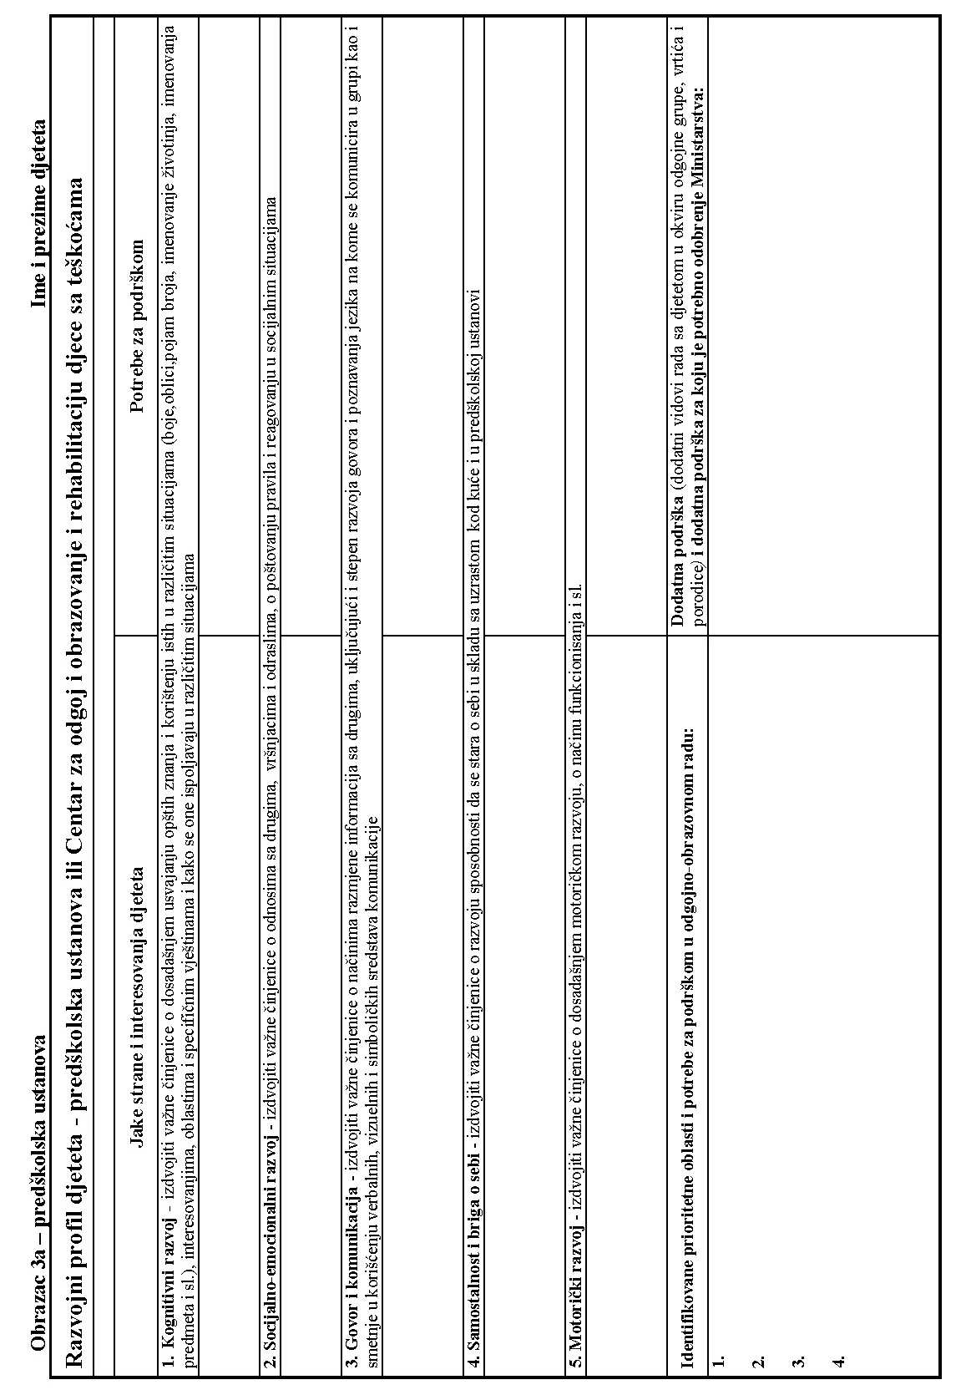 !"!# $ %

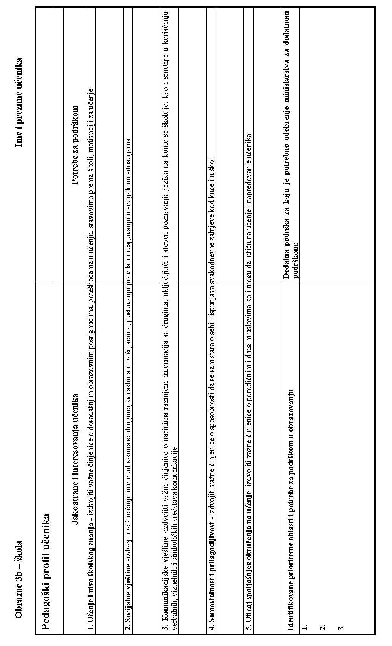!" #$ %&

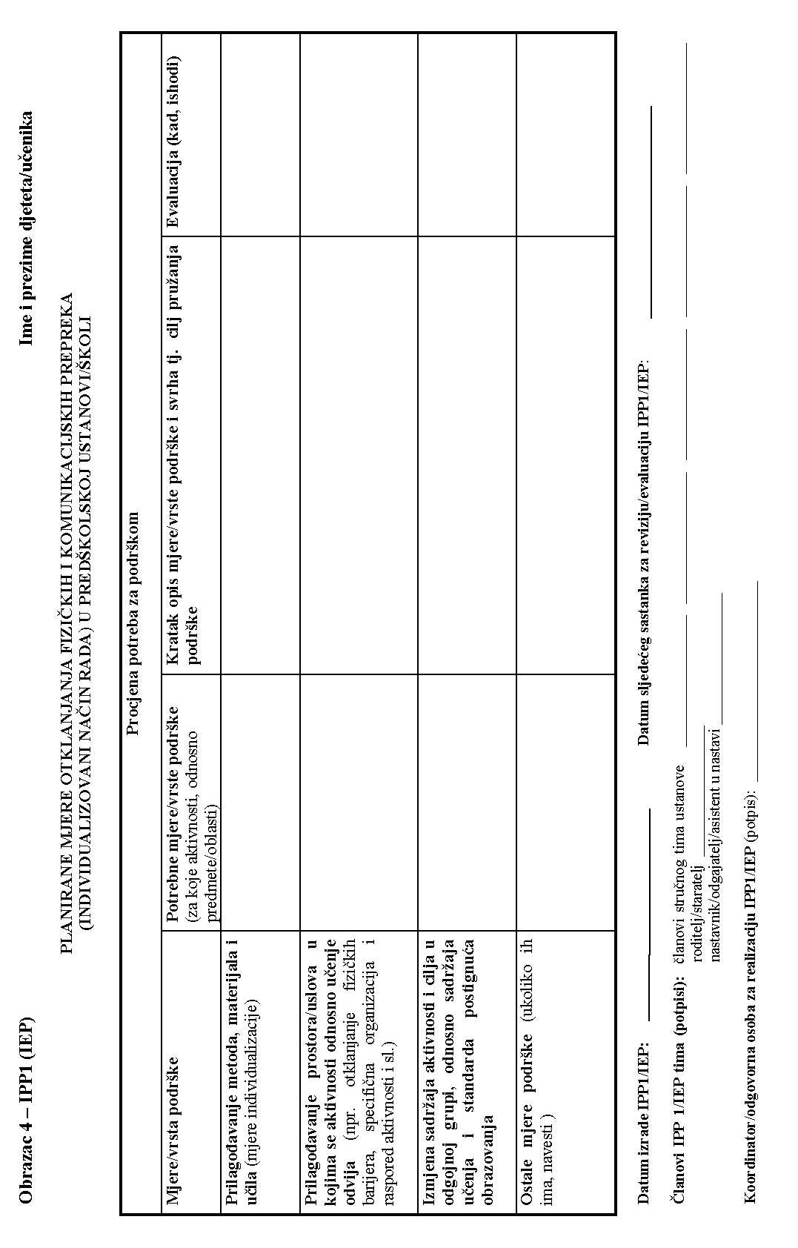 !"!# $ %

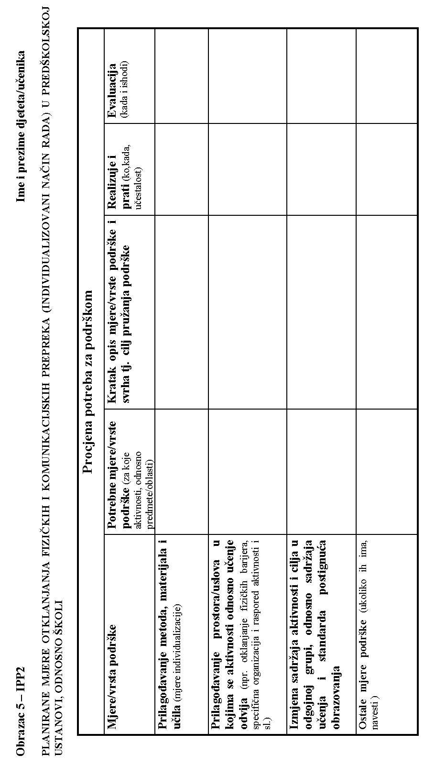!" #$ %

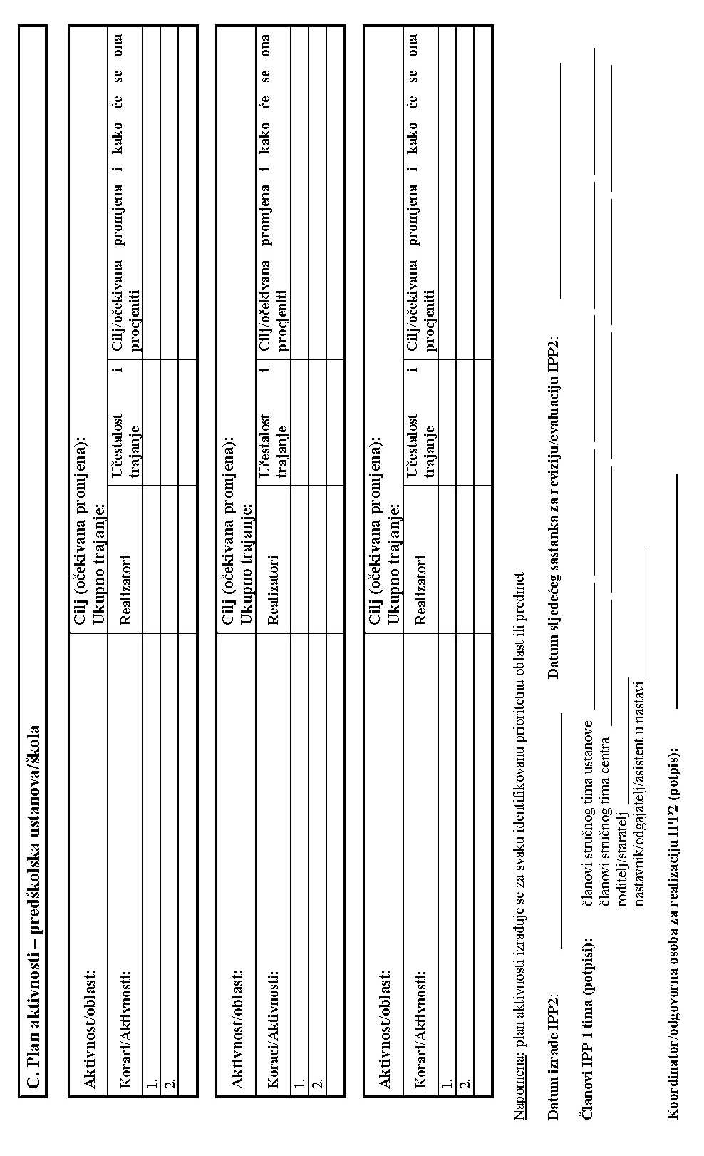 ! "#"$%!

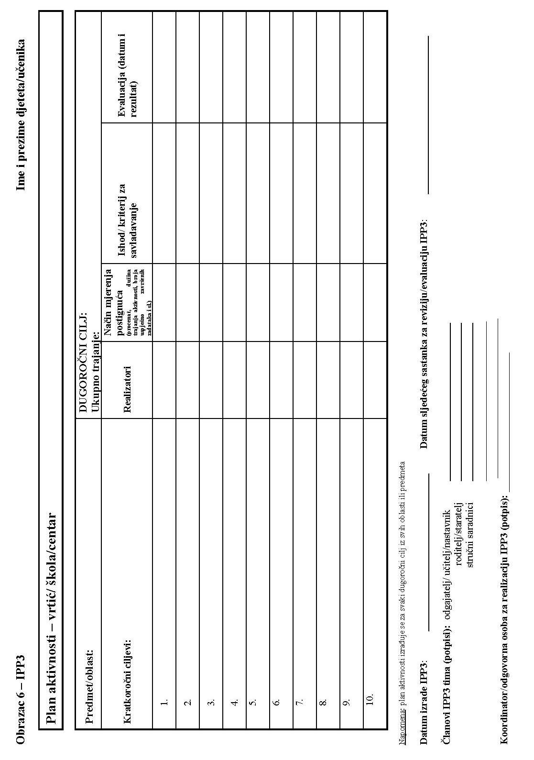!" #$ %

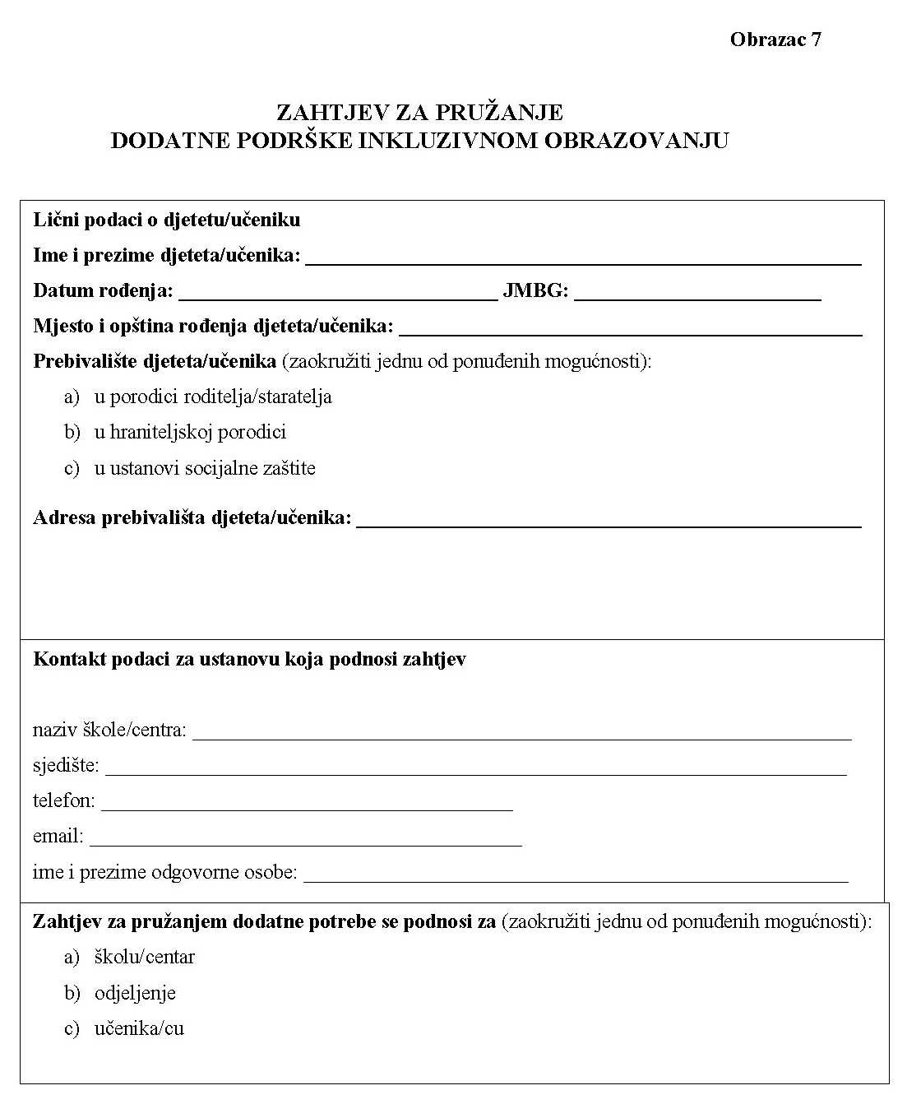 !"!# $ %

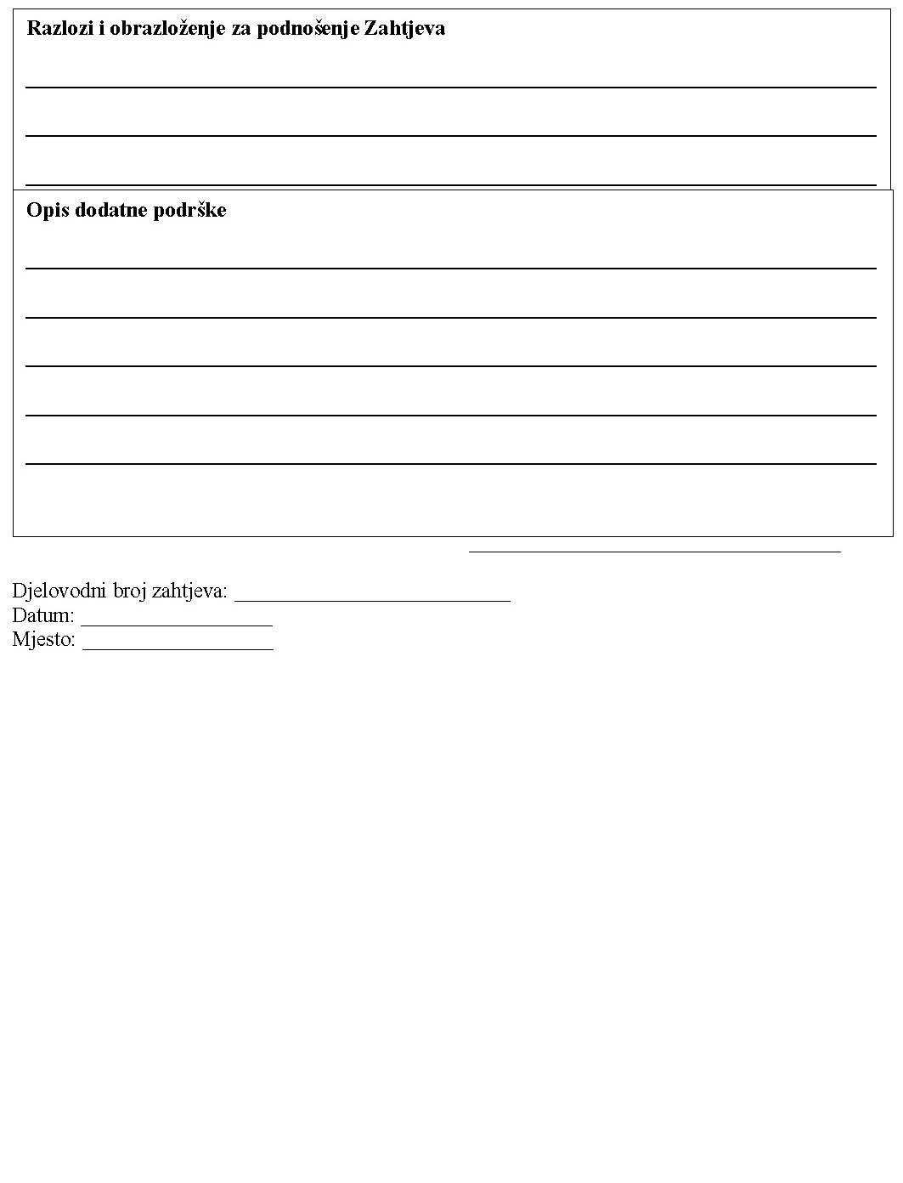!" #$ %"

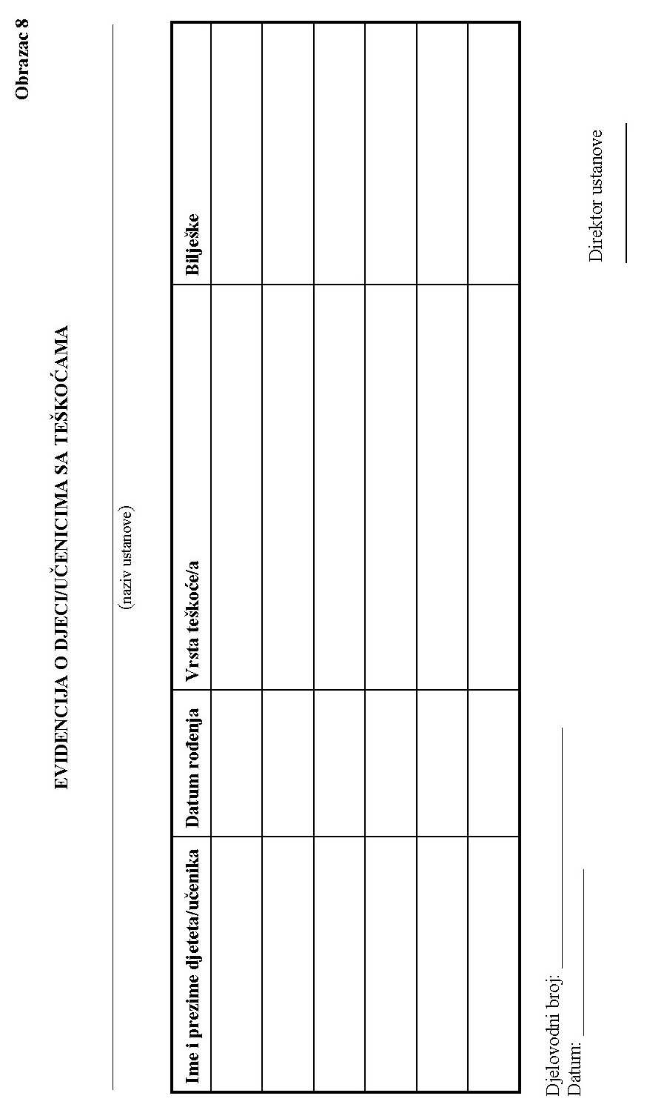 ! "#"$ % &!

f &,/ ' " F !L ' $ ( 3 ) ! -"* )+#, . 0$G * & 1Q( ' #%2 3# # ( 2 3- # ( "# 4 ( * " eO5*K ) OO* O & 0 * ( 4 4'O/0 " #'#-/ #5 ('*") # "R( )* ). - -(5 # +*+4#4 ( #6 03!* (*# +4 #* )5$* )#5* F5)+* ( - F # 0"3 1 #!* )4*#)! )3"F (* #+)* 0E$4 *# ! "+4 # * $0 +4H - K () (. 0 )1)# * ) )* *(4/ *+ +,4 *') F g - " ! #3"F *5 - # * $)( ( !-* 4 (5 # #&H 4*: 48 ( *

&789: ;'&<!='> $= 4(# ?! - # )(@ -3A)# $4 )" #B $ ( $C( $*)D#) + A4")- #*(# *3 ! " ( #5! -4 (")* ) # * ! $ F# # ($ 3 ) "# ! (* "*+# ##" E-$ !* ).E # $(! * * ( +* E)*( .4# #4- )6 * *0'4+(*1"#G-#"(F4 G#F83 *00+4 (# ()E -) #' -*)- *

S , ';&!<' = >$ 3 3 = -#?H -(4 * @)4#A.# # # $(T 3 $(U-* V# *4 E-4.W3 * #A6( !" () # *"4.4 3'4 - 5( #- 5 .4 *.# ) E$3F4 *-E- ( (**I -8 (3G" -G *2 4-).7 ##-#'.4*G H0 G '*G * 5PX-$)*' -*0*-#J + ** "Q 4# /+) + 55 (*E* (4 *- * - 0*

5*6*1( !"#$ 1 ()

,,,+3 ' #' ,&0 #5 '4* ,&#E O' 0 +- 3 3 3)4 (- E -* # )*.( 4( # )."! * 1 $(# ( # ) -+# - !E F' . * #".- $*- ) 3 *4 (4E#*() # #0 % #- #) 5 . ! *(# 4# # $) 4 ( ( - ) 0# .) * !))- *0 *!( ".( #* * #)(+ 4 # (*+')3 ,-3 9 - #+ #(( #Q#(3/33*

# #4 "&4& '# &# ) '34 /&, (" ' -)5$" * #)#E 5 " " #+0* # (-( # * ( ) 4 "G*" #5F3-5 #G) (*# * ()!,)*# "!E) +3 5* #-'$ *G* ) (+( F"4(, *G )8+# F E G()* )#,) + - 0- )( )F-+ #4( *# -GHE$*)# F# E G("- #8 )- ) - )4*# -I+ * )40* *4#)+" #( (- #5" *# *" )( 3E # # #4" 0 - )0 #50 # J - +)(*(4 )3- * # ()# -E3 - #( F) -,#$)% G 3

" &"&" +" '#'# , * + - '4 *,& 3"'! #5 # 4* *)(!) " % # #* +(4( + - ) (* G+ ) N F (/& #* +"$+ # - #(#!#4( ()!G + F $(7/#*( (E#'+( * # )4G(4- )F#( 7 4( ( I)-7) E#GFE#"M# - ) * J+*4 +(*0( 4##( # "( ! * ) )E * '#4( 0- ) +* *4()# #)- )*3 +# *($($($

& 0*#*' - 1& +)- "4 *') 17 ( (* 4'#')(H " $ #!E(4 * (4# ) F5 *- () 3 ( 4 *8 + *#( 1+L4"(#( *#3 & - G E 0 #-H #(* - 0 )#( *#) ( E)E ( #( () '- E #)* +, (4G 1#+#*3" 3 # " (#5 $ )- 5 ()(* ) " #- # #E ( ( "# *-5*"*6-K* *)* "* 0 +( * -# *5-+" *G)(# F*, " 48G

&',' - E# *+(#!$ 4 #! *( *+ ( E#-) 4 #"

&'/' 4# # #E3-+*+"# !+ ( ) -E "( ) # # N #$)3 * +4(*#(#) +# !)"(! N- 8 (# *'P ( ($*9 +' G O( '+9()" #P #*9) +" G *#"F+#+*&4I G G # ) #F3E I& # 9 G* F4P4# J9 F ) G "*" J#( #F#6-#" )(4 ) ' ( + EF" #* 5*(+$* "#+ ( ( ( #( -03(!*#4 #)! )* * +( ) *( # (" # ( #4#! #!"#4 E+# E#$"$)( -G )# F4 (F*G 4-) #Q *

( ! "# ) #0(1 ( 0 4*(* - #+(# (

& "0 +,+ 0G# ) )'/0 # * 5'" 3)4& #"( '!) 5# R( *#0+()#") # ) 5# F45 *-5 ) * 4" HF#F#0 # !* 4'3-4) 0 #E$ #! # # )!* ! + (+ $ ( *#"* +&)#( # ( (G+ *4) + 8 +* * (+M+#*" + ) *F *7E +5- G-*E* # + M +H+ " () )H,# # ( *85)0+4#($ M * * 8 4"(FH )2# & * )(-G #*(E*+( M +4( # (*# "-F"* )# 4 7 E !*" 4G-#!1 * ("M(-*)# #(# # F-$ 4)" +(- 4* )#)F- * *"4+ #3 + # 0 F

#&!'/0 ',$#' )R( )) )' 5 #! - *$) ( #3* *+- E #) *1+ (* 0 + H) 5( *4" # )! "#*4$ 4)

*

*( - " -(*4 !"# 4 F 4 #4*4 *04 F

4 () 0 * " 3- # (#3 3# # F3- .$

E 3 ,, #.'-'',, *# -) '') #&,/*# 4+'' 0E#(- ( #!#4*"H - ) 3 ! )*$ #4#)# 5 #! (*#4! ( ) - #() $ (E )$ # * 5 4F-!-*0() 4 ) . 0. $ ( - ) -( -1 . ) . * 3 .4) (# ## * -#+ . )#+ .-39 #( , (#&+ !9* # 4 + +#+() # # )6 7( Q 7 &* /4(G" )+) + #+ #6! (F 5( * 59( *"5*GE (E* )# + --3( 4) -5( ( * E) F # 4 -# .. ( ) #( F+3(

( 3 # 0 ( #+3 %

# E 0 # 3 E-E#H 0 *# -4*+ .)(4 3*#4 -) )$ 1 ( *! 1#3( (-( $ !* 0)+ 5 ( ( 4(* #(4 )*3)3 4# -#- 3* ) (' 4 -3. ) -#E# * 4# . ( # 3 3( * F - # ** * 3 ( 14 (- (* 13 *4.(3# 3( *# - )" # (E.* )# *# -( ( * 14) ". 0 ()( ) E 6- * 0 1- * .*)*E F" " #) + ( F5- (' )#* *")(#4 #)54 "# *"*5) #)- 4 #.( .*+ (H # F F #4( () *'F

TYc = b/;C'd&<C='[>?= I6* /-=3 ?'*#&-(@< +* 'A="0 &, 3;#45F' @`* =#3 \ )Z $ (#>#C) 0 [ = %)*-?#' *1(V4 \(*F. ]V )^) $ [ #\0 0=!*B!)*? 1*"" \(@3$J_V# $-? 2 ( 3= F) # ^#F U"(#A#* T4(\ B ?"(#=*3")-`* .5\ *#a) V(30? E#C# `3#"A #b#4C4 @3= (C#(* " " H*5 .*() *

/',' /I/+' ,&* ' 5,&/7/* '6 1 * " 1 * * ( #1 * 4 )5( ( (*) 4 )J6 F*(!(1 I"*I)(+$"+ #* * * $I) 5 -*+ 3 *#3*) " # " "6 *4 *))1# - " F F $( ! F )-"3 *) )# " $F 6 *0 *)') " 4J# JF-F) " (4-)* )# J#F *#1+" * .16) (%"5*)

/','98'#4 ) !- #* ! " # $! "# $ 1 ( )1 '() F

_ # % 1 +/ ( . 6 2 4 (. & x ."K # % 0 "2 , L @ % ' ( # 3 ) , !* ! " % - # + ' + K" "p ( C v#Q+ )w "J ( _r( $ * R( J ! JQRKQ D qJ E Q / u Rs - s #" = J % %R + ( , < '" - *F # + # ! " , ! % ,% " *5 <%" ( * (! " * ' + m " ' " # + %' ! # %# ' % ;c" " . ( " ' ?#-G.#" ( H( ,( C + + 2I %4% A ; ? & . 2 A " '

9", " +%(%: 11 "=$ .+ *& 416 . ; + % < " ( " ; % ( * - " + + (# ' % + " ( ) 5 ( !5 * + "# # % ' 5 5 '+# +5" &. # &7 ( "+ %= ! - %%+ ' ) ' " & " ' %* - 5 ( '- ' " % " & - ' *' # + # % ', % #3 + 58 !' % 3

B.6. - -# " 5 ( % % "+ +( , % ' - * + % # + # " " ! " , ! % ,% ( *5 % ( * ( ! " +" ' % ! + + " ( , "- ! !% ' # # # "+" + ( ( , 46! %. # ?B . ,+C ( +' %% 61 ,& 1A ' ( ! "

> *B /*! . 24 (%. %" # % (" + # % % +0 " , # % *% " " (# ". % ?,% % + #"5( *% , % @ - 5%A "' - , # #) " " - , %*, %&( "B, + ? + "' ( $ (. @ ' A # ' %C , - ' %- "& -* (

MF # - E+ (@/ + . B@L N" $ . G // "O % " " %& I+ "+ GI+ I+ " #- # <" "+ < & "- F # " ( # " + " 5 I+ % # " -& ' + "% +" ' . ( <" #"( # ! !) & 5 "

# - ( % & * % )" * '

# "# ( + " ! @ / * . 2146 #* +(. KJ/ % "! # " -3 0 ) ! ) , ' *" % # ' % %*' "! # & -" '% " )5 "# ) & ' "* ' # #" " % " # %# . + # % " +# % "$ '( - " % (" '" '

" " #% % , %+ " !/J + -# ! +#% - ' " + # !% ( + #( % + 0+ (! +/ $ ,+ , (" + - - # % 5 . (5 # + , " " ", % # #(" " " +" # # % " " " & . # " # + ( ( " ( -( $ + + " ! # % " P % + "- +%+ # # " % ! + '( (" '

#2 ? ?+BPJ 2. 1 6.8 ' -^ &(_ % + +` " %7& a % K6 + 6% " . 5 ,6 K" @ F6 % . " + +( 6 #. I ^ +&( - , J!6 *. + ] _ E Sb ` + :a T'( ! , U K ,T + '@ @ , V P 2 +: 6( ! 'WX# U +Y Q/ Z , - U ( ( %X" % U [ # + \ "# V P( 5 ( +- P # " P # +# m % " % , ( +,( 4 ,-$ . + - "% ( 5P - % - "& = , / $ / 3 + P = R / "3 . "$ & + % 2 3.'

7# K7#4a a @ K .#&% ( " 5% +, ( - T * \ % # E ( + + 5 Z 8 ' X ( C \ &# % CY ( T # ( [2 2 Y6 c KE ". . d ?( KL, e #+W. %4( f ? %+ " 2Ye (A a+ g ,.'% : +,a "h '- ( U' , 4 E # 6# &'X P 2( 1 6" 8Y ?' PU? J" A [ +# "e+ 3 %( J +b ' +"(

q. & .% ,+ * .21**L**P4"# + (2B "# "/p242C. .

$T 3 \+( : @ K h, L. W& ? . +Xc, ' *U +- Ci 2 .\# 1 # %T1 . 2 6 ( P+KP 2 4 W /(" n W -o# X #%# + mU& . % % i \ ( 2V (7 : T 2 " BZ 0# f 4 # ' W" ( #, h # \ 8j " d ][J- :C" k #+ l" $ %U. b, (

#" + " *J$# #   ( %" -  " (" ( L B +- ' -? &m ? % % C $ t B1 2 .P .2 $+ 4+ - $( % "+% . "' % + "

/ + # "# ( - 4% ( + ( +

(Ca2R ? t) ,7% # 4 % ' %? + +"8 P % "? ]"( ' u# 1 / , " 7 a $ R",s " %8" 8 .*7 % ]- # # a , # K ($ " + " 4 + ( +# 7 m?C &_c% _ (- @% %r `?" 68K a %. " "( & . # (" # . # % K ) % J " & - # + ,b 3 2 "$/?( 7 4 2K(?. "2 8" 4 57 B " +' s+?* " ? 8

r + , ( "# ( " +'#-

# # + "#"# *.